Microsoft logo

Robotic Process Automation in a Day

Lab 8 – Web automation using Power Automate Desktop

90 mins

April 2023

Applies to Power Automate Desktop v. 2.31.105.23101 ([more](https://learn.microsoft.com/en-us/power-platform/released-versions/power-automate-desktop))

This document is provided “as-is.” Information and views expressed in this document, including URL and other Internet Web site references, may change without notice. You bear the risk of  
using it. Some examples are fictitious and are for illustration only. No real association is intended  
or inferred. This document does not provide you with any legal rights to any intellectual property in any Microsoft product. You may copy and use this document for your internal reference purposes.

© 2021 Microsoft Corporation. All rights reserved.

## Lab Overview

You will complete the following tasks in this lab:

* Exercise 1 – Build a Power Automate Desktop subflow to write notes into Microsoft Excel
  + Create a process with fixed value variables.
  + Test and run this process.
* Exercise 2 – Web automation using Power Automate Desktop
  + Web data scraping and writing to Microsoft Excel.
  + Test and run this process.

## Prerequisites

Please complete lab 1.1, pre-requisite task 3: Start per user plan with attended RPA trial license and lab 1.3, installation of Power Automate Desktop. To use Power Automate Desktop, a user must own either a trial or paid per user plan with attended RPA.

Before doing the exercises, please complete Lab 2.

# Exercise 1 - Build a Power Automate Desktop subflow to write notes into Microsoft Excel

In this exercise we will create a process in Power Automate Desktop which will write the values of variables that we already created earlier into a Microsoft Excel file.

1. In Power Automate Desktop, Edit Enter an invoice flow you created by clicking … icon and select Edit.

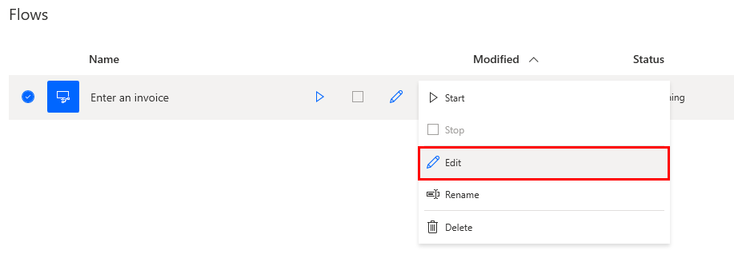

1. Click Subflows > plus icon to create a subflow for Enter an invoice.

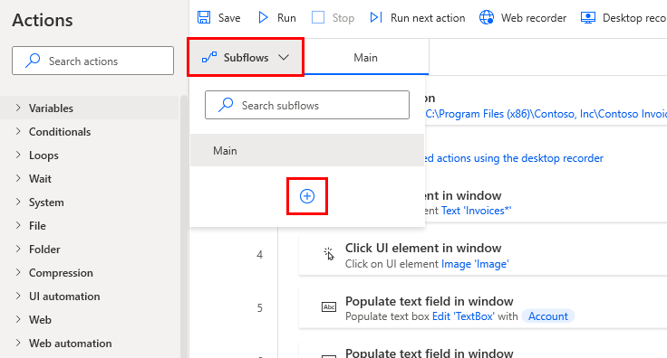

1. Name it Write_notes_into_excel. Click Save.

Note: Subflows’ names can’t have spaces.

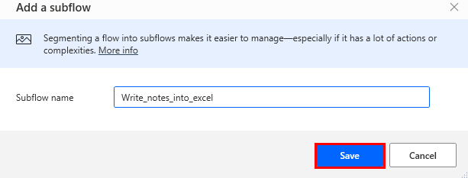

1. Drag and drop the Launch Excel Action from the Excel folder.

1. Set Launch Excel to and open the following document and click on the Select File icon.

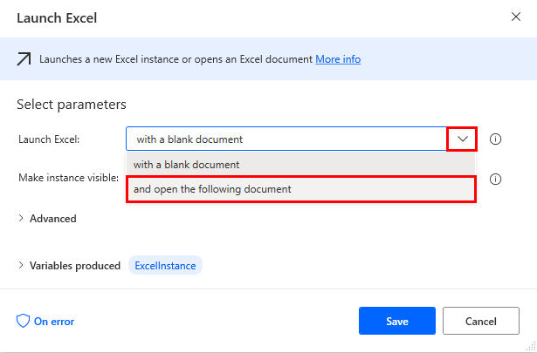

1. Save the file Contoso Invoices.xlsx that you can find inside lab data packages/Lab #9 excel file to use in Power Automate Desktop folder to the folder of your choice, then browse for it in this dialog, select it and click Open.

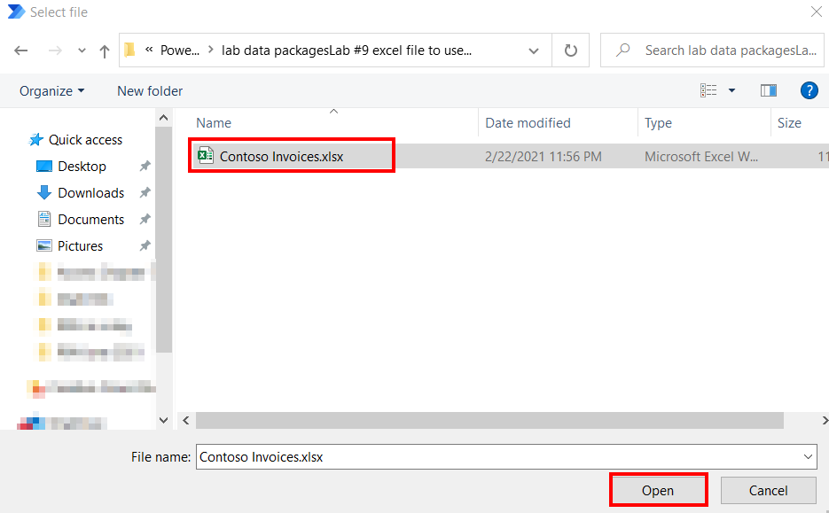

1. Information Only – Our spreadsheet does not contain a password. However, if our spreadsheet did, we could provide a password in this field. Then click Save.

1. Drag and drop the Get first free column/row from Excel worksheet action from the Excel folder.

1. In the Action Properties, we will use the default settings for this action. Click Save to add it to the design surface. This action will retrieve the number of the first free row and the first free column and store them into variables.

1. Drag and drop the Write to Excel Worksheetaction from the Excel folder.

1. In the Action Properties, in Value to write, open the Available Variables by clicking on the Select InvoiceID icon, double click InvoiceID.

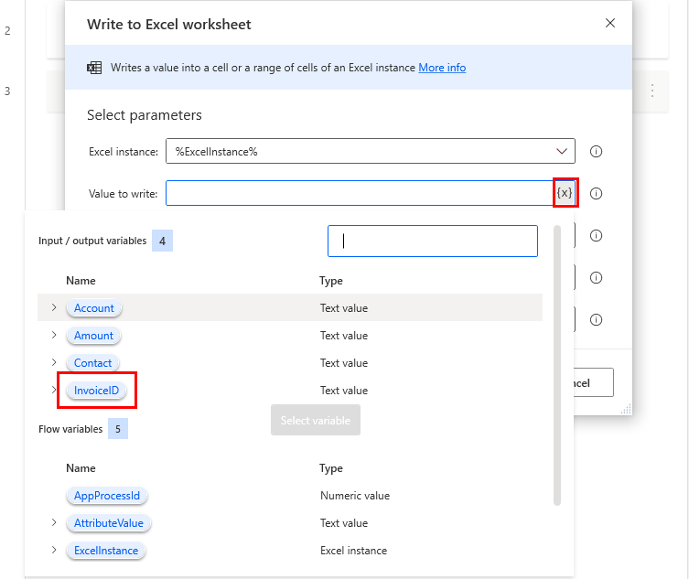

1. Enter A and in field Column, then in Row, click on the corresponding Enter A and in field Column, then in Row, click on the corresponding   icon, and select %FirstFreeRow%.  icon, and select %FirstFreeRow%. Click Save

1. Repeat the three previous steps, writing values of variables to cells as the table below. For all Columns, Row must be set to %FirstFreeRow%.

|  |  |  |
| --- | --- | --- |
| Value to Write | Column | Row |
| %Account% | B | %FirstFreeRow% |
| %Contact% | C | %FirstFreeRow% |
| %Amount% | D | %FirstFreeRow% |

1. When all the steps above have been completed, your subflow for writing notes into Excel should look like this:

1. Click the Save button and then go back to your Main flow by clicking Main.

1. Drag and drop the Run subflow action from Flow Control folder under Step 12.

1. Call Write_notes_into_excel subflow you just created. Then click Save.

1. Click on the Savebutton to save the flow.



1. You can now run your flow by clicking Run.
2. After the automation run, check the Excel file and you will see the following entry should have been added:

excel file added a new column after subflow run successfully

Note: You may see a different invoice ID here.

# Exercise 2 - Advanced Power Automate Desktop features

In this exercise, we will use the web automation to convert the total amount into another currency and add that converted to the Excel document.

1. Open Microsoft Edge(Chromium)**,** enter this in the browser URL address bar: **edge://settings/system.** This will bring you to the SettingsthenSystem page. Uncheck Continue running background apps when Microsoft Edge is closed.Close all browser tabs and sessions before you proceed.

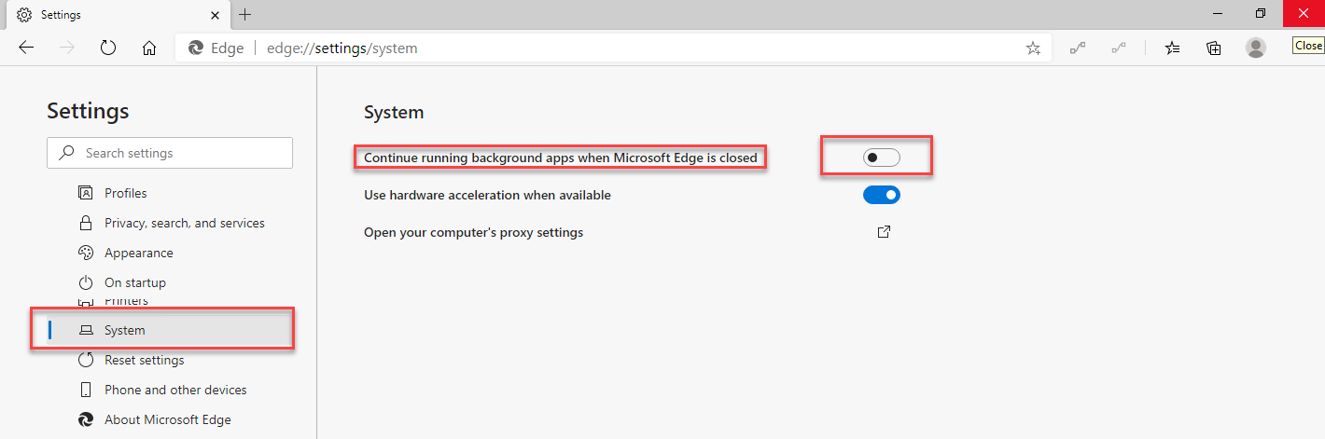

1. In Power Automate Desktop, Edit Enter an invoice flow you created by clicking … icon and select Edit.

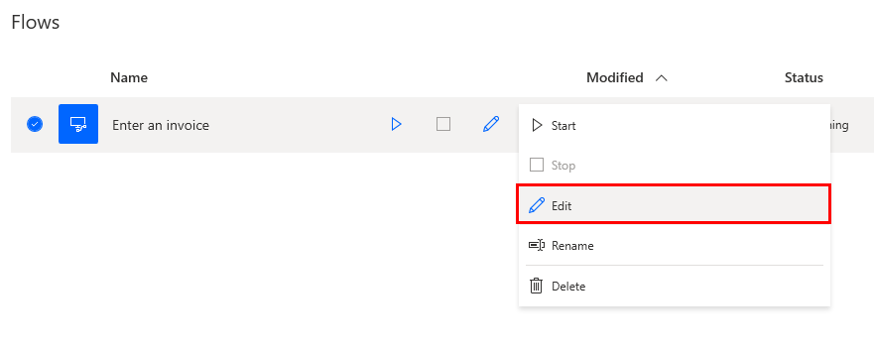

1. Click Subflow > plus icon to create a the second subflow for Enter an invoice.

1. Call your Subflow Currency_Exchange. Click Save.

**Note:** Subflow name can’t have spaces

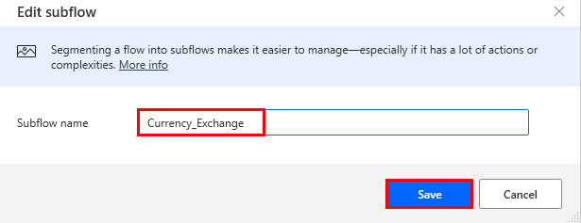

1. Drag and drop the Launch new Microsoft Edge Action from the **Browser** automation folder into the workspace.

1. In the Initial URL field enter: <https://www.msn.com/en-us/money/tools/currencyconverter>
2. Click Save.

1. Open an Edge web browser and navigate to [**www.msn.com/en-us/money/tools/currencyconverter**](http://www.msn.com/en-us/money/tools/currencyconverter)This will be the website we will be using to lookup real time currency conversion rates.

1. Now we will enter the total amount value from AI builder model as the US dollar amount, into the website input textbox to lookup the converted value.
2. First, we need to enable input on the currency field on the website. To do that, we need to click it with mouse. Select **Click link on web page** action from **Browser automation** group.

1. The Web Browser Instance is already populated with the %Browser% instance.
2. We need to identity the textbox UI element on the webpage that takes US dollar as input. To do that, click on the UI element textbox and then click on Add a new UI element to be able to capture the element.

1. Having done this, a small Tracking session window will show up to capture UI element. Open the browser webpage, and you will see a red rectangle appear in the webpage while hovering the mouse over different elements. Move the mouse over the text field containing the US dollar value and hold the Control on your keyboard and Left-Click using mouse to select the element.

1. Once you selected the element, you will see the value appearing in **UI element** field. Click Save.

1. Add another action which will send the previous Total amount input value into this UI element field. Use **Populate text field on web page** action from **Web form filling** sub-group.

1. Again, click Add UI element button to grab the input field that appeared after the value was clicked on the website.

1. Hover over the input field. Once a red mask appears showing the type of the UI element (Input text) hold the Control on your keyboard and Left-Click it using mouse to select the element.

1. You can notice that the selector was recorded and is now present inside the **UI element** field. Next select the **{x}** icon in **Text** field, then choose **Amount** value and press **Select** button.

1. Under Advanced turn on settings: **Populate text using physical keystrokes** and **Unfocus text box after filling it**.

1. Select **Save** buton.

1. Now we can test this subflow by selecting the first action in the subflow, right click and select Run from here.

1. You should see the automation run and convert $500 amount (the default amount value) into another currency

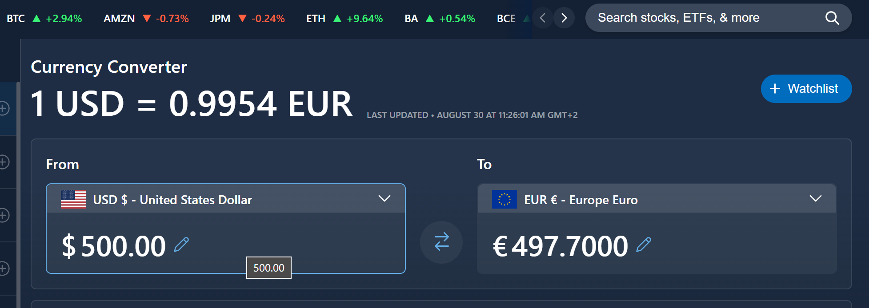

1. The next step is we will capture the real time converted value from the website. We will use the Get details of element on web page action in the Web data extraction subfolder to select the converted value (Euro) using the same method described above.

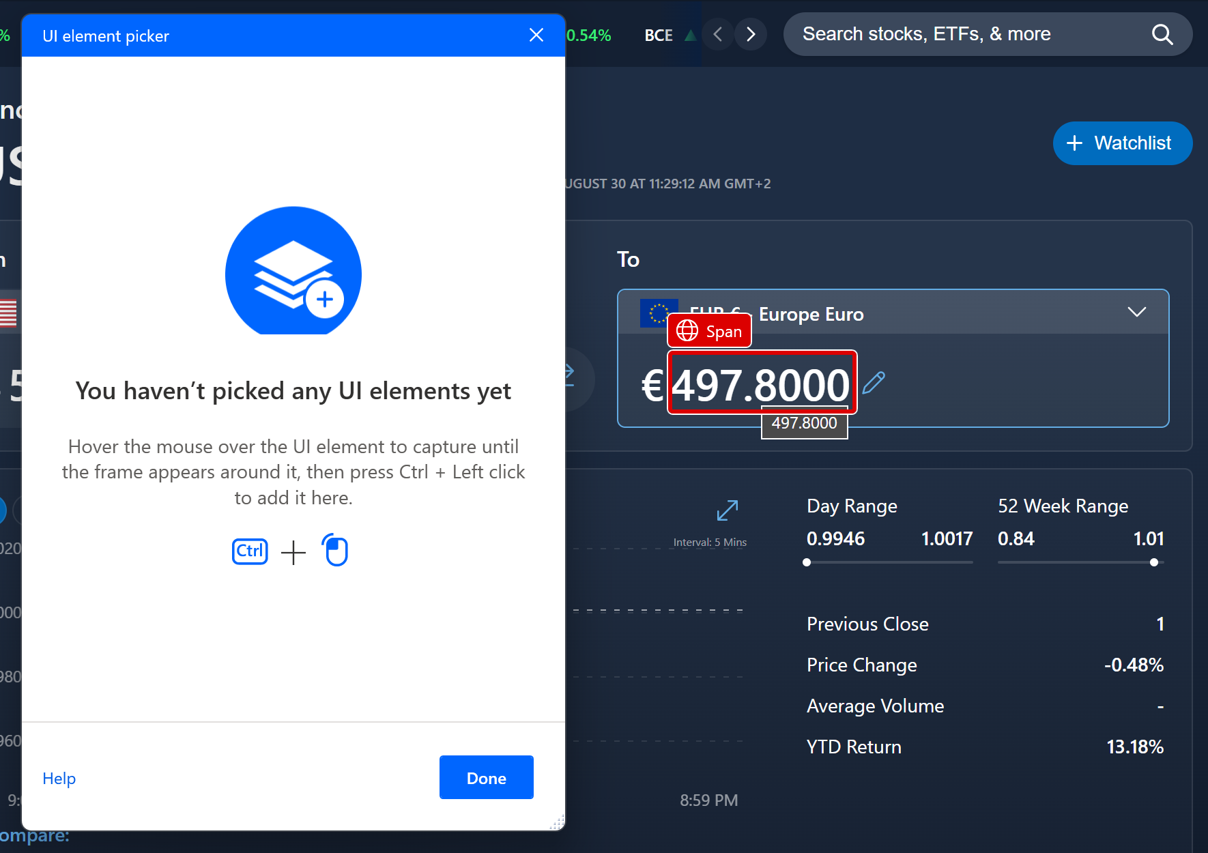

1. Change the Variables produced from %AttributeValue% to %ConvertedAmount% by clicking into %AttributeValue%. Once you’re done, click Save.

1. Click **Save**. Then go back to Write_notes_into_excel subflow you created in exercise 1 by clicking Write_notes_into_excel.

1. Add the Write to Excel Worksheetaction from the Excel folder under Step 6.

1. Writing values of variables to cells as the information below.

* Value to write: %ConvertedAmount%
* Column: E
* Row: %FirstFreeRow%

And click Save.

1. Now we will add the **Currency_Exchange** subflow into the **Main** flow before **Write_notes_to_excel** subflow. Go back to your Main flow by clicking Main.

1. Add a Run subflow action from Flow Control folder as Step 12 of your process.

**Note:** this subflow should be called prior to the **Write_notes_to_excel** subflow call.

1. Call **Currency_Exchange** subflow you just created. Then click Save.

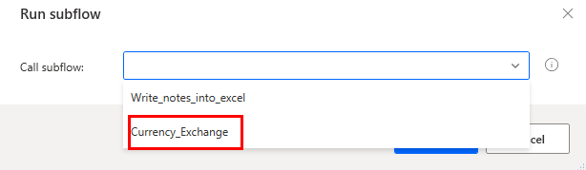

1. Click on the Savebutton to save the flow.



1. You can now run your whole main flow by clicking Run.



1. After a while, an entry is added to the Excel file as in the previous exercise, with an additional cell containing the converted value:



Check your knowledge

Lab 8

5 mins

1. Which of the following can you use as your Subflow name?
2. Currency exchange
3. Currency Exchange
4. Currency_exchange
5. All of the above

Answer: C. Currency_exchange. Power Automate Desktop does not allow for spaces to be in the name of a Subflow.

1. When you try to capture a web element from a web page, after selecting the Click link on web page action and clicking UI element dropdown, you need to select _______ to be able to capture the element.
2. Add a new UI element
3. Save
4. Browser
5. None of the above

Answer: A. Add a new UI element - You need to click this button to start capture elements

1. When you are populating text Field on web page, you need to hold the _______ and _______ to select the element.
2. CTRL + Left-Click
3. Tab + Left-Click
4. CTRL + Right-Click
5. Tab + Right-Click

Answer: A. CTRL + Left-Click

Information in this document, including URL and other Internet Web site references,  
is subject to change without notice. Unless otherwise noted, the example companies, organizations, products, domain names, e-mail addresses, logos, people, places, and events depicted herein are fictitious, and no association with any real company, organization, product, domain name, e-mail address, logo, person, place or event is intended or should be inferred. Complying with all applicable copyright laws is the responsibility of the user. Without limiting the rights under copyright, no part of this document may be reproduced, stored in or introduced into a retrieval system, or transmitted in any form or by any means (electronic, mechanical, photocopying, recording, or otherwise), or for any purpose, without the express written permission of Microsoft Corporation.

Microsoft may have patents, patent applications, trademarks, copyrights, or other intellectual property rights covering subject matter in this document. Except as expressly provided in any written license agreement from Microsoft, the furnishing of this document does not give you any license to these patents, trademarks, copyrights, or other intellectual property.

The names of manufacturers, products, or URLs are provided for informational purposes only and Microsoft makes no representations or warranties, either expressed, implied, or statutory, regarding these manufacturers or the use of the products with any Microsoft technologies.  
The inclusion of a manufacturer or product does not imply endorsement of Microsoft of the manufacturer or product. Links may be provided to third party sites. Such sites are not under the control of Microsoft and Microsoft is not responsible for the contents of any linked site or any link contained in a linked site, or any changes or updates to such sites. Microsoft is not responsible for webcasting or any other form of transmission received from any linked site. Microsoft is providing these links to you only as a convenience, and the inclusion of any link does not imply endorsement of Microsoft of the site or the products contained therein.

© 2021 Microsoft Corporation. All rights reserved.

Microsoft and the trademarks listed at https://www.microsoft.com/enus/legal/intellectualproperty/Trademarks/Usage/General.aspx  
are trademarks of the Microsoft group of companies. All other trademarks are property of their respective owners.